


Accessibility Plan
2024-2027

Category | Compulsory under Equality Act 2010
Next Review Date | Every 3 years unless changes to legislation  June 2027
Policy Availability | Academy Website
Officer Responsible | Principal

Contents

1. Introduction 2
2. Vision and Values 2
3. Aims 2
4. Legislation and guidance 3
5. Monitoring arrangements ……………………………………………………………………………………….…….3
6. Action plan 4

1. Introduction
Schools are required under the Equality Act 2010 to have an accessibility plan in place. The purpose of the plan is to identify the actions the school intends to take over a three-year period to increase access for those with a disability in three key areas:
- Increase the extent to which disabled students can participate in the curriculum
- Improve the physical environment of the school to increase the extent to which students with a disability can take advantage of education, facilities and associated services
- Improving the availability of accessible information to students with a disability

2. Vision and Values
Shireland Collegiate Academy Trust is an inclusive trust that highly values a holistic approach to supporting all staff, students and their families.
Everyone who works with and for the Shireland Collegiate Academy Trust does so because they believe in children and want their futures to be happy and successful.
This approach is underpinned by our values of Innovate, Inspire, Collaborate which are supported by our core behaviours.

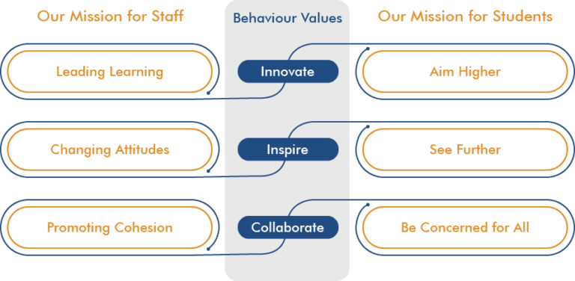

3. Aims
The key objectives of this plan are:
- To reduce and eliminate barriers to access the curriculum and to ensure full participation in the school community for students and prospective students with a disability
- To provide a caring and friendly environment without discrimination of any kind
- To provide resources to cater for the needs of individual students
- To promote and understanding of disabilities throughout the school

Our school is also committed to ensuring staff are trained in equality issues with reference to the Equality Act 2010, including understanding disability issues. The school supports any available partnerships to develop and implement the plan.
The plan will be made available online on the school website, and paper copies are available upon request. Our school’s complaints procedure covers the accessibility plan. If there are any concerns relating to accessibility in school, the complaints procedure sets out the process for raising these concerns.
The school has included a range of stakeholders in the development of this accessibility plan, including students, families, staff and governors.

4. Legislation and guidance
This document meets the requirements of schedule 10 of the Equality Act 2010 and the Department for Education (DfE) guidance for schools on the Equality Act 2010.
The Equality Act 2010 defines an individual as disabled if they have a physical or mental impairment that has a ‘substantial’ and ‘long-term’ adverse effect on their ability to undertake normal day to day activities.
Under the Special Educational Needs and Disability (SEND) Code of Practice, ‘long-term’ is defined as ‘a year or more’ and ‘substantial’ is defined as ‘more than minor or trivial’. The definition includes sensory impairments such as those affecting sight or hearing, and long-term health conditions such as asthma, diabetes, epilepsy and cancer.
The school is required to make ‘reasonable adjustments’ for students with disabilities under the Equality Act 2010, to alleviate any substantial disadvantage that a disabled student faces in comparison with non-disabled students. This can include, for example, the provision of an auxiliary aid or adjustments to premises.
This policy complies with our funding agreement and articles of association

5. Monitoring arrangements
This document will be reviewed every 3 years
This document may be reviewed and updated more frequently if necessary and if changes to legislation require it.
This document will be approved by the individual school Standards and Performance Committee.

6. Action plan
This action plan sets out the aims of our accessibility plan in accordance with the Equality Act 2010.

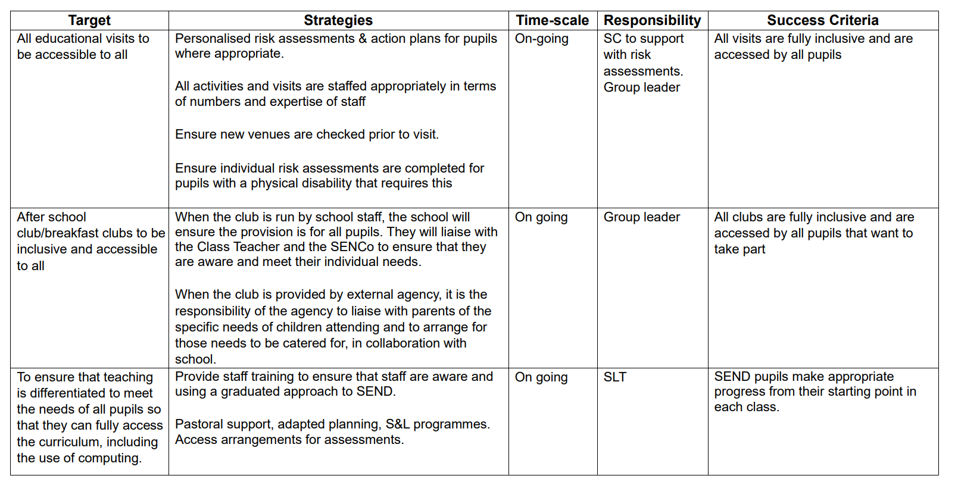
1. Increasing access for disabled pupils to the school curriculum.

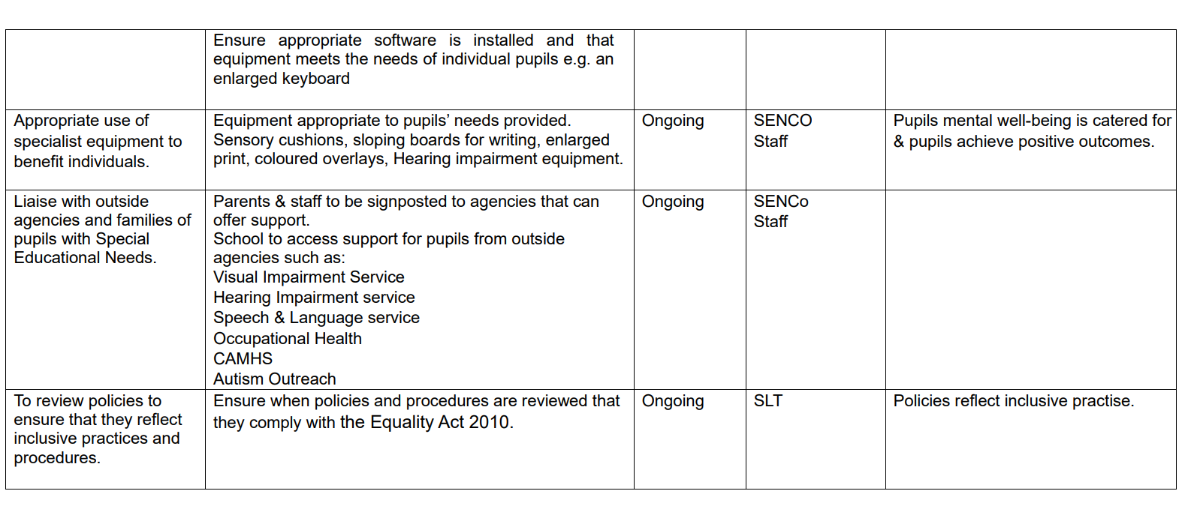
2. Improving access to the physical environment of the school Provision, in exceptional cases, will be negotiated when a pupil’s specific needs are known as they enter the school.
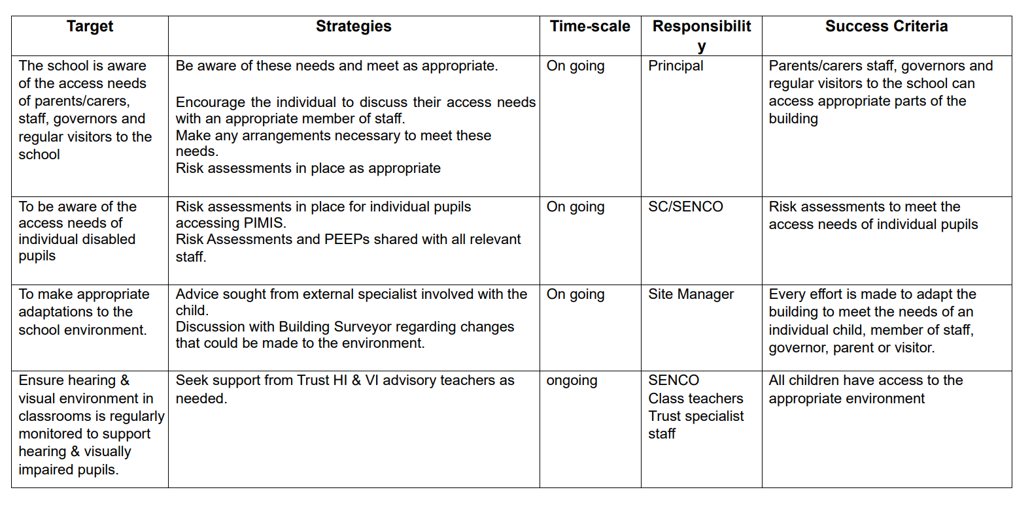

3. Improving the availability of accessible information to disabled pupils This will include planning to make written information that is normally provided by the school to its pupils available to disabled pupils and parents. Examples might include hand-outs, textbooks and information about school events. The information should take account of pupils’ disabilities and pupils’ and parents’ preferred formats and be made available within a reasonable timeframe.

